ECON 100B Spring 2026
Midterm Exam
Rules and instructions:

- You have 60 minutes to complete this in-class exam, worth 60 points in total.
You must stop working when time is called. If you continue working, you will be penalized 10 points, then an additional 10 points, and so on until you turn in your exam.

- When time is called, stop working, stand up, and go give your exam to a proctor or place it in the receiving box. Do NOT give it to another student. Students who fail to turn in their exams promptly will receive the point penalty stated above.

- This is an open-book, open-note exam, but notes are limited to 1 page double-sided. We suggest that you bring a stand-alone calculator. You might find a ruler useful.

- PROHIBITED: Internet, texting, all communications. No laptops, smartphones, screens.

- Your work on this exam must be your own. Violations earn a zero on the exam and a referral to the Center for Student Conduct. Sign the Berkeley Honor Code below:

“As a member of the UC Berkeley community, I act with honesty, integrity, and respect for others.”

__________________________
(your signature)
- Write legibly. If we can’t read your answer, we can’t award credit. Confine your answers to the space provided (inside the box). Don’t fill the space with words. Less is more.

- Restroom breaks are allowed. Give your phone to a proctor and retrieve it afterward.

- If you see something, say something to a proctor. Pretend to go to the restroom and tell a proctor briefly what’s going on. If you prefer, write something on your exam instead. If you are the victim of academic dishonesty by another student, take countermeasures.

(1 point) Write your name and student ID at the top of each page of the exam.

(1 point) If you are in Pimentel Auditorium, record your row letter and seat number.

(1 point) What is 2 + 2? (George Orwell fans earn extra praise, but all students earn this point.)

1. (15 points total) Short questions, short answers, Get Shorty (1995)

- (3 points) If you were the leader of a country, and you had the choice between more capital formation and more idea production, which one would you choose and why?

- (3 points) For a profit-maximizing firm, what do we typically call the marginal product of labor? What do we typically call the marginal product of capital?

- (3 points) True or false, and briefly discuss: Holding everything else constant, a country with more population growth will be a country with higher living standards (meaning income per person).

- (3 points) In India, the annual growth rate of GDP is about 8%, and the annual growth rate of population is about 1%. What is the growth rate of Indian GDP per person? Briefly show your work. Does this number seem low or high compared to growth rates in advanced economies like the U.S., Europe, and Japan?

- (3 points) Suppose a country had weak societal institutions, meaning that its government could not protect its citizens against theft, and that government sometimes stole resources from its citizens and threatened to imprison them if they objected. What would citizens of this country likely do if they could? What would they likely not do?

2. (22 points total) Saving rates and other things across Solow economies

Recall the Solow model expressed in ratios, with capital per worker $k=K/L$ on the horizontal axis. When output is Cobb-Douglas with capital share equal to $1/3$,

capital per worker $k=K/L$ (2.1)
output per worker $y=A{ k}^{1/3}$ (2.2)
saving per worker $s y=s A k^{1/3}$ (2.3)
depreciation per worker $(n+d)k{}_{}^{}$ (2.4)
marginal product of capital $MPK=\frac{1}{3}A{\left(\frac{L}{K}\right)}^{2/3}=\frac{1}{3}{A k}^{-2/3}$ (2.5)
marginal product of labor $MPL=\frac{2}{3}A{\left(\frac{K}{L}\right)}^{1/3}=\frac{2}{3}{A k}^{1/3}$ (2.6)

Consider two Solow economies in which $n=0.01$ and $d=0.04$ and the level of total factor productivity $A$ is the same, but the saving rate in Solow economy A is $s^{A}=0.20$, while in economy B it is $s^{B}=0.15$. Assume these two economies have the same level of population.

- (4 points) Depict both Solow economies on the same axes below. Show output per worker, saving per worker, and depreciation per worker for each country. Some or all of these may be the same for both countries. Show the steady state(s). Discuss what you have drawn. (Explicitly showing the wage and MPK is optional but might be helpful.)
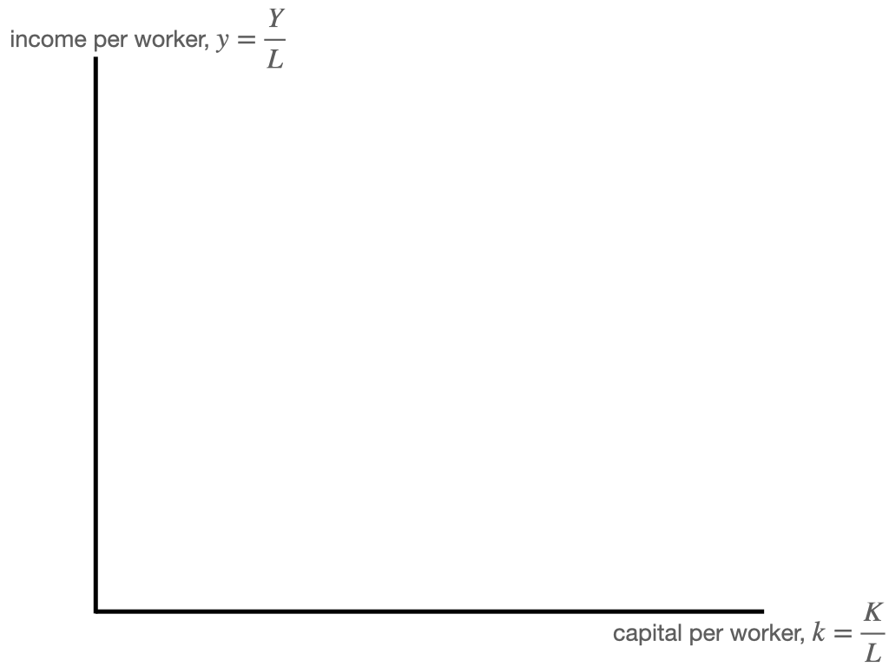
- [2 points] In which country is the wage higher, or is the wage the same in both countries? Briefly explain, referencing math or the graph or both.

- [2 points] In which country is the interest rate higher, or is the interest rate the same in both countries? Briefly explain, referencing math or the graph or both.

Factor inputs like labor and capital probably seek higher returns, meaning that if labor and capital are free to move across borders, each one will try to move to where its return is highest.

- [2 points] Under the circumstances described above, where would labor seek to migrate? Into country A, into country B, or would labor seek to remain where it is? Take a stand and briefly explain

- [2 points] Under the circumstances described above, where would capital seek to move? Into country A, into country B, or would capital seek to remain where it is? Take a stand and briefly explain.

- [2 points] Suppose labor was restricted from moving across international borders but capital could move costlessly. Qualitatively speaking, how would saving per worker shift between country A and country B, if any, and in which direction? Make a reference to the graphs that you drew.

- [4 points] Recall the scenario in part (f). Suppose saving could be exported as manufactured capital goods. Which country would be running a trade deficit, meaning that it imports goods from a different country? Discuss.

- (4 points) Suppose capital was restricted from moving across borders but labor could move both costlessly and continuously, not just once. Draw a new Solow graph that shows both economies on the same axes below, but illustrate the effects of continuous labor migration that fully offsets the effects of the original differences in the saving rates between countries A and B on wages. Show output per worker, saving per worker, and depreciation per worker for each country. Some or all of these may be the same for both countries. Show the steady state(s). Discuss what you have drawn. (Explicitly showing the wage and MPK is optional but might be helpful.)


3. [20 points total] Brain drain and brawn drain in a drawn Romer economy

Consider two “old school” Romer economies A and B, with production of knowledge $A_{t}^{i}$ by scientists $L_{at}^{i}$ and of food $Y_{t}^{i}$ by farmers $L_{yt}^{i}$. Quantities in the economies are denoted with a superscript $i=A,B$ so that output in economy A is written $Y_{t}^{A}$. The equations are familiar:
$Δ{A_{t}^{i}}_{}={\bar{z}}^{i}A_{t}^{i} L_{at}^{i}$ (3.1) ${\underline{N}}_{}^{i}=L_{at}^{i}+L_{yt}^{i}$ (3.3)
$Y_{t}^{i}=A_{t}^{i} L_{yt}^{i}$ (3.2) $L_{at}^{i}=𝓁^{i} {\underline{N}}_{}^{i}$ (3.4)
Assume nothing is shared across the two economies. Recall the solution, plus a helpful elaboration about what income per person is, in equation (3.8) below:
$g[A_{}^{i}]={\bar{z}}^{i} 𝓁^{i} {\underline{N}}_{}^{i}$ (3.5)
$A_{t}^{i}=A_{0}^{i} (1+g[A_{}^{i}])^{t}$ (3.6)
$y_{t}^{i}=A_{0}^{i} (1-𝓁^{i})(1+g[A_{}^{i}])^{t}$ (3.7)
$y_{t}^{i}=\frac{Y_{t}^{i}}{L_{at}^{i}+L_{yt}^{i}}=\frac{A_{t}^{i} L_{yt}^{i}}{L_{at}^{i}+L_{yt}^{i}}$ (3.8)
- [4 points] Suppose that the only difference between these two Romer economies is that economy A started with a higher level of ideas: $A_{0}^{A}>A_{0}^{B}$. All other parameters are the same. Graph $y_{t}^{A}$ and $y_{t}^{B}$ on the same axes below and briefly explain what you’ve shown. Discuss levels and growth rates. Be precise and succinct.
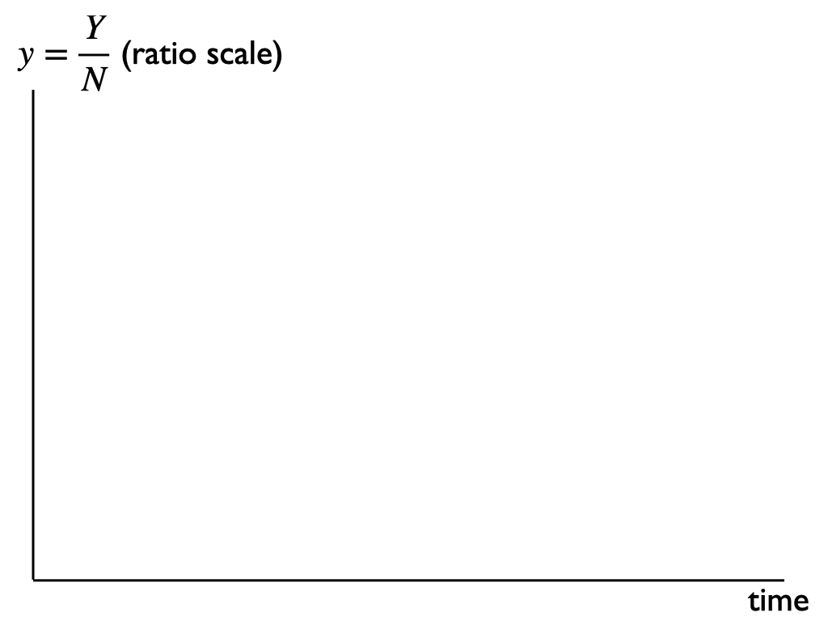

- [2 points] Consider a farm worker in country B. If this worker had the option to migrate to country A, would the worker want to do so? Assume workers have access to local technology and average incomes. Take a stand yes or no, and make a brief argument.

- [2 points] Consider a scientist in country B. If this scientist had the option to migrate to country A, would the scientist want to do so? Assume workers have access to local technology and average incomes. Take a stand yes or no, and make a brief argument.

- [4 points] Suppose that a large number of farmers migrate from country B to country A and remain farmers. Depict what would happen, if anything, to income per person in both countries. Briefly explain. Discuss levels and growth rates. Be precise and succinct. Hints: Pay special attention to numerators and denominators. Look at equation (3.8).
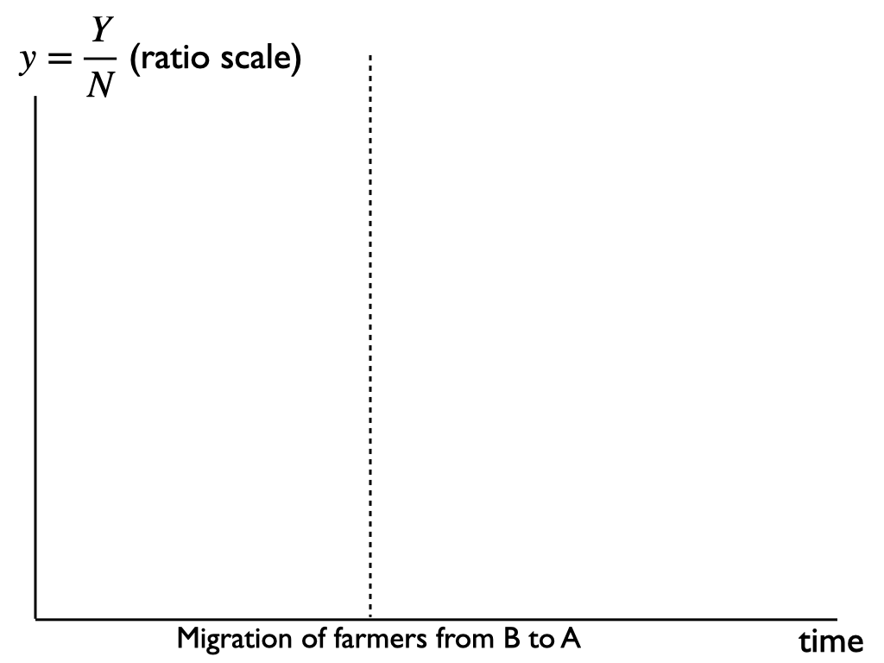
- [4 points] Now suppose that a large number of scientists migrate from country B to country A and remain scientists. Depict what would happen, if anything, to income per person in both countries. Briefly explain. Discuss levels and growth rates. Be precise and succinct. Hints: Pay special attention to numerators and denominators. Look at equation (3.8).
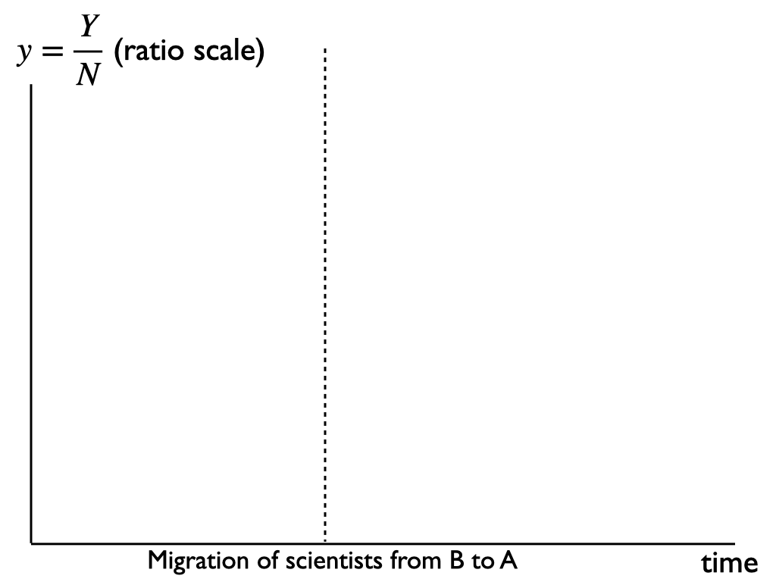

- [4 points] Discuss what your results imply about the macroeconomic effects of immigration in the Romer model. Does the average resident (who enjoys income per person) of immigrant receiving countries like country A always benefit from immigration? Does it depend on the type of worker who migrates? Does it change over time?

Note: Here and throughout the exam, take any political views that you like, or none at all. Scores reward completeness of answers only and will not penalize any political viewpoint or the lack of one.

